
GRIFFITH COLLEGE LIMERICK

Software Development Project Initial Specification Cover Sheet

Student name: | Valentin Gnidyi
Student number: | 3054010
Faculty: | Engineering, Computing & IT
Course: | Bachelor of Science in Computing Science (Honours) Degree |  |  | Stage/year: | 4
Subject: | Software Development Project (SDP)
Study Mode: | Full time | X |  | Part-time
Lecturer Name: | Sonia Zheleva
Assignment Title: | Project Proposal Initial Specification
No. of pages: | 6
No. of words: | 950
Additional Information: | (i.e., number of pieces submitted, size of assignment, A2, A3 etc)
Date due: | 18.10.2023
Date submitted: | 17.10.2023
Plagiarism disclaimer:
I understand that plagiarism is a serious offence and have read and understood the college policy on plagiarism. I also understand that I may receive a mark of zero if I have not identified and properly attributed sources which have been used, referred to, or have in any way influenced the preparation of this assignment, or if I have knowingly allowed others to plagiarise my work in this way.

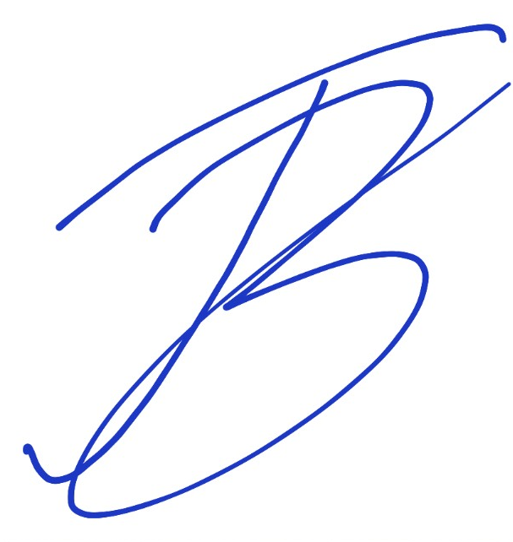
I hereby certify that this assignment is my own work, based on my personal study and/or research, and that I have acknowledged all material and sources used in its preparation. I also certify that the assignment has not previously been submitted for assessment and that I have not copied in part or whole or otherwise plagiarised the work of anyone else, including other students.
Signed: _____________________ Date: ___17/10/2023_____

GRIFFITH COLLEGE LIMERICK

Bachelor Degree in Computing Science
(Honours)

Marketplace for Local Artisans
Android Mobile Application

Project Initial Specification Form

The form, fully completed, must be returned to:

Sonia Zheleva
Faculty of Engineering, IT & Computing
Griffith College Limerick
O’Connell Avenue
Limerick

PROJECT TITLE: | Marketplace for Local Artisans
STUDENT NAME & ID: | Valentin Gnidyi 3054010
NAME OF DEPARTMENT: | Engineering, IT & Computing
PROGRAMME | Bachelor Honours Degree in Computing Science
MOBILE NO: | +353 833 840 408
EMAIL ADDRESS: | valentin.gnidyi@gmail.com

Initial Specification:
Project Description:

Nowadays, local artisans often can struggle to represent their crafts and gain recognition that they deserve. The proposed for development mobile application as a Marketplace platform can not only help with selling their crafted products, but as well help to establish better social connections with other craftsmen and increase the arts and crafts cultural awareness inside a local community.

The application will provide the option for the public to make online purchases from local artisans and be aware of live gathering events, where they can meet up with the craft makers and view their products. For artists, the application will provide a platform to share ideas (over the Themed Forums section), sale products (as online Point of Sale system), and make self-advertising (over the Gathering Events News Feed section).

Key Features:

- Appropriate content
- Appealing interface design and product listing
- Intuitive navigation
- Secure Personal data and Safe financial transactions.

Functionalities:

General Public (Customer) Intefrace
- Online Registration, creating Customer profile.
- Secure Login process (with option to re-set password)
- Local Artisan Search with Geolocation Services:
- Implement geolocation services to show the artisans and their products within Customer’s vicinity, encouraging support for nearby businesses.
Allow Customers to search for local Artisans, based on location, product category, or specific keywords.

- Place Order and Secure Checkout:
- Allow Customers to request product(s) from selected Artisan and Product Category and implement a secure and user-friendly checkout process, including the option for guest checkout and order tracking.

- Payment Processing:
- Integrate a secure payment gateway to facilitate transactions with Digital Wallets.

- Wishlist and Favourites:
- Allow users to create wish lists and mark favourite products for easy future reference or sharing.

- Notifications and Alerts:
- Set up Alerts for users to receive updates on new products promotions, or events from their favourite artisans.
- Receive Notifications of Placed Order status (accepted/rejected/processed/paid)

- Product Reviews and Ratings:
- Enable Customers to leave reviews and ratings for products purchased and service obtained.

- Community Events Listing board:
- Include a Listing board of local artisan events, markets, or fairs to further engage with the artisan community.

- Social Media Integration:
- Allow users to share their purchases or desired products on social media platforms directly from the app, promoting the local artisan marketplace.

Artisan Interface:

- Artisan Registration & Login
- Offline Registration process with contact information, performed by the System Administrator to prevent online impersonation.
- Secure Login process with option to change (reset) password.

- Artisan Profile Creation, Product Listings, and Updates:
- Allow artisans to create a profile, showcasing their work, including a portfolio of products by categories, with description, pricing, pictures, which will enable them to upload images and details of their products, including categories such as handmade crafts, artwork, jewellery, etc., and to update information.

- Order Management:
- Provide tools for artisans to manage orders (view submitted order requests from customers, send Notifications of acceptance/rejection of order requests, send Invoices for accepted orders, and update order status (accepted/processed/paid), track shipments, and communicate with buyers. Include order history.

- Payment Processing:
- Receive Notifications for provided Payment of Order Invoices.

- Promotion and Marketing tools:
- Include features for artisans to promote their products, such as discounts, limited time offers, and social media sharing.

- Products Rating and Comments from Customers:
- Allowing to view the comments left from Customers.

- Artisan Community Forum:
- Create a forum/community space, where artisans can connect, share tips, and discuss their craft.

Technical and Non-Technical Resources Required:
Hardware:

- Laptop;
- Android OS based mobile phone

Operating System:

- Windows 10
- Android OS

Software:

- Android Studio /Android Studio Emulator/ Gradle
- Google Firebase
- HTML5/CSS/XML
- Java/Kotlin/React Native
- 3rd party Digital Wallet

Tools, equipment, and other sources:

- Internet
- YouTube tutorials
- MS Office
- Udemy.com
- Android Emulator
- Google Forms
- DRAW.io
- Balsamiq
- Integration with Google Maps

People involved in the Project:

- Project Supervisor – Sonia Zheleva

Student Signature: Date: 17.10.2023

Supervisor Signature: Date:

